KL
Q1
The graph below can be optimally partitioned using the KL algorithm. The dotted line represents the initial partitioning. Assume all the edges have the same weight.

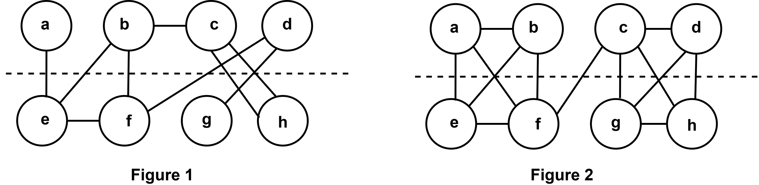

(a) | What are the common steps of Physical Design? | [2]
(b) | Find the iteration number in the first pass of the KL algorithm for Figure 1. Calculate the costs of moving each node from one partition to another in Figure 1. | [2]
(c) | Perform the first iteration of the KL algorithm for Figure 1 and swap the best pair of nodes. After that, find the old cut cost and the new cut cost. | [7]
(d) | For Figure 2, the best gain value of different iterations is given below,  $∆g_{1}=3$  $∆g_{2}=5$  $∆g_{3}=-6$  $∆g_{4}=-2$  (i) Calculate the cumulative gain of every iteration of the first pass.  (ii) Are any further passes necessary? State the reason for your answer. | [4]

